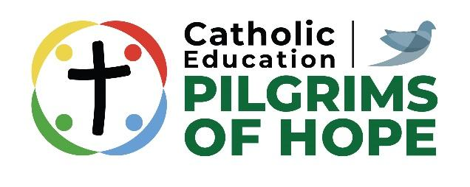

DRAFT LETTER TO MEDIA
(from either the school board or the school principal)

Dear Editor:

During the week of May 25 to June 1, 2025, the _________________________ Catholic School Board will celebrate the significant contribution that Catholic Education has made to the community, the province and to Canada. Our Catholic expectations challenge students to articulate in society those fundamental values that underpin Catholic education.

The theme for this year’s Catholic Education Week is:

Catholic Education: Pilgrims of Hope
L’éducation catholique: Pèlerins de l’espérance

The theme for Catholic Education Week 2025 was inspired by the following considerations:

- In February of 2022, Pope Francis announced that the theme for the upcoming 2025 holy year would be “Pilgrims of Hope.” “We must fan the flame of hope that has been given to us and help everyone to gain new strength and certainty by looking to the future with an open spirit, a trusting heart and far-sighted vision. (from Vatican News, a short video on the history of the Jubilee/Holy Year: https://x.com/VaticanNews/status/1783768498885275868)

- The Holy Father asks us to focus prayerfully on the bonds that unite our whole human family, to reflect on the rampant poverty in our world, and to think about the plight of the many refugees forced to leave their homes. He also summons us, as stewards of Creation, “to contemplate the beauty of creation and care for our common home.”

- A pilgrimage is a spiritual journey of movement toward a goal, often lived together with others – and that certainly describes Catholic education. Hope – one of the three theological virtues – is grounded in our Easter faith in Jesus’ resurrection and renewal; this is what enables us to be builders, dreamers and leaders in Jesus’ name. Pope Francis invites us to keep moving ahead in faith, in joy, and in hope, as part of a pilgrim people. Even in challenging times, our eyes are focused on the future.

There are five sub-themes, one for each day of Catholic Education Week and they are aimed at helping staff and students to reflect more fully on what being Pilgrims of Hope means to them. The five sub-themes are:

Day 1: By honouring human dignity / Honorent la dignité humaine
Day 2: By caring for creation / Prennent soin de la création
Day 3: By responding to the poverties in our world / Luttent contre les pauvretés
Day 4: By serving in solidarity / Servent en solidarité
Day 5: By living as peacemakers / Vivent en artisans de paix

Catholic Education Week is marked by special activities at all grade levels, including prayer celebrations and service activities.

I invite you to visit our school(s) during this special week and to participate in any of our activities as we celebrate Catholic Education Week 2025.

Sincerely,
(Director of Education or School Principal)

