Prayer to Open a Advent/Christmas Celebration

Let us begin our prayer, in the name of the Father, and of the Son, and of the Holy Spirit. Amen.

God our Father, you fill us with excitement and hope as the celebration of Jesus’ birth draws near. May the hope and joy of your Holy Spirit ring out in our hearts and echo throughout our gathering this evening. And may your holy angels join us with their choruses of heavenly praise.

We ask you to bless with your peace all who have prepared us for this performance; bless our voices that we might confidently sing to your glory. And may this celebration this evening help ready us to receive that same joy and peace that filled the stable at our Saviour’s birth.
We make this prayer to you in the name of Jesus, your Son. Amen.

In the name of the Father, and of the Son, and of the Holy Spirit. Amen.

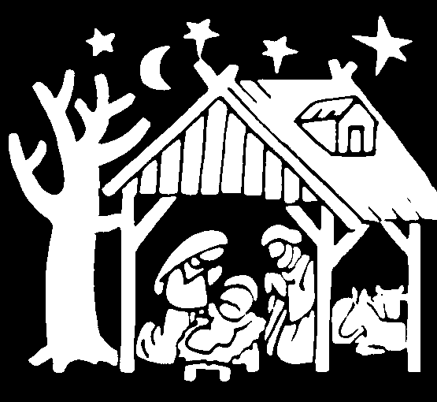

Adapted from a creation by T. Cosentino Renfrew County CDSB, 2012

