Catholic Education Week Supporting Materials:
Intention:
For the students and staff of our Catholic Schools as they focus on the theme of ‘Catholic Educaton: Opening Doors of Mercy’ during Catholic Education Week, may their celebrations help all to recognize the need everyone has to be accepted and loved. May we open wide the doors of our hearts to others, we pray to the Lord.
Bulletin Announcement:
Catholic Education Week 2016 will be celebrated from May 1 - 7. This year’s theme, Catholic Education: Opening Doors of Mercy, suggests a focus on living with one another as a people of mercy. We are called by Pope Francis to “bring good news to the poor, proclaim liberty to captives and the oppressed, and restore sight to the blind”. All schools will be celebrating the enduring gift of Catholic education with special prayers and presentations. We ask that this parish community pray for our Catholic schools. May they always be places where the doors of mercy are open.

Media Announcement:
Catholic Education Week May 1 - 7, 2016 – Catholic Education: Opening Doors of Mercy

We have been created by God and taught to be merciful, just like our heavenly Father. We have been told that whoever sees us sees God. We turn our focus to celebrating the open-ness we have to sharing mercy with one another. Our theme, Catholic Education: Opening Doors of Mercy, refers both to the doors of our buildings and the doors of our hearts.

There are five sub-themes, one for each day of Catholic Education Week, aimed at helping students and staff to reflect more fully on what being merciful people

The five sub-themes are:

Day 1: Mercy that Welcomes
Day 2: Mercy that Loves
Day 3: Mercy that Forgives
Day 4: Mercy that Lives the Gospel
Day 5: Mercy that Rejoices

Catholic Education Week is marked by special activities at all grade levels, including prayer celebrations and activities.

We invite you to visit our school(s) during this special week and to participate in any of our activities as we celebrate Catholic Education Week 2016.

(continued)
Trustees’ Announcement:
Good Morning/Evening,
My name is ______________________ and as a trustee for _________ Roman Catholic Separate School Division, I am pleased to share with you an introduction to Catholic Education Week. This week is especially set aside to celebrate who we are as Catholic schools, what we are as Catholic schools and how the triple connection of home, parish and school is an important part of Catholic Education.
For this upcoming week of May 1 - 7, our schools will celebrate the theme ‘Catholic Education: Opening Doors of Mercy’. Throughout the week we will reflect on what it means to be merciful like our heavenly Father. We will focus on the different ways we can show mercy to others and be merciful to ourselves.
Join us in the upcoming days to share in the prayer services and special activities at our school(s). Information regarding these events can be found on School websites or learned by contacting the school office.
Thank you.

Poster:
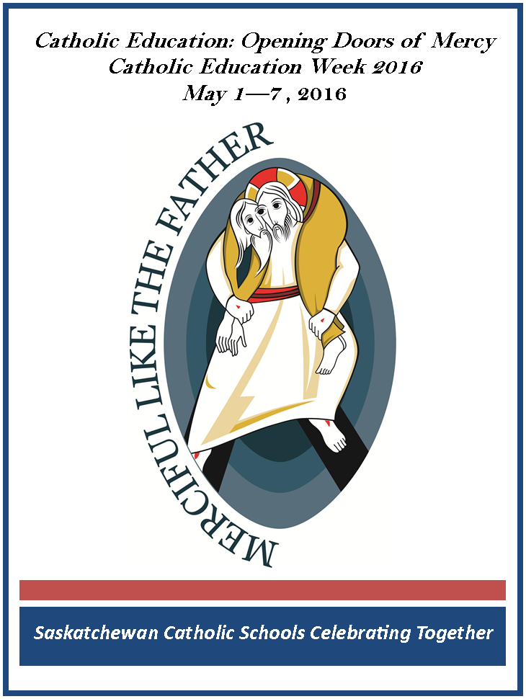 (attached as pdf)

