Kindergarten Seven Weeks of Easter
based on a prayer by Cathy Yohnke
(note: some of the colouring pages in this document can be resized, cut and pasted on a blank page and printed out)

First Week of Easter
Review the Good Friday story briefly. Tell the children that you want to share some Good News with them. Read the story of the resurrection (from a child’s picture Bible). Discuss the story. Why do we celebrate Easter? Can you imagine how happy the friends of Jesus were when they saw him again? Stress that this is a very happy season. Distribute a treat from an Easter basket. (Ask the parents to sent Easter cookies or treats during this Easter season rather than the week before Easter. Explain to the parents who might not know, the tradition of fasting during Lent and the fifty days of celebration after Easter). Talk about the celebrations at church. Talk about Easter flowers that decorate homes and churches at this time.
Action Poem (based on the Memorial Acclamation)
We remember that Jesus died, (stand with arms outstretched in a cross)
We rejoice that He is risen (bend knees and stretch arms from knees all the way up until standing on tiptoes with hands high up in the air)
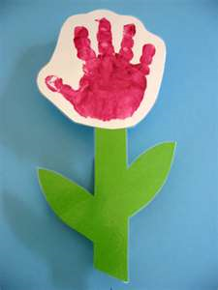
We know that He will come again. (Bring arms down and cross them on chest)
Alleluia! Alleluia! (Twirl twice)
Art Project
We use our hands to rejoice that Jesus is risen. Paint the child’s hand to make a hand print on colored construction paper. The handprint (one or two or three) is the flower. Paste on stem and leaves. Use these pictures to make a bulletin board display. ‘Rejoice for Jesus is Risen’

Second Week of Easter
Use a flannel board (or …?) to retell the story of the Resurrection. Encourage the children to supply the sequence of the story. Celebrate with another treat from the Easter basket.
Action Poem (based on the Memorial Acclamation)
We remember that Jesus died, (stand with arms outstretched in a cross)
We rejoice that He is risen (bend knees and stretch arms from knees all the way up until standing on tiptoes with hands high up in the air)
We know that He will come again. (Bring arms down and cross them on chest)
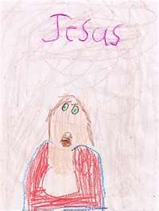
Alleluia! Alleluia! (Twirl twice)
Art Project
The children color and cut out a picture of Jesus (with his arms outstretched) and paste this to a sheet of colored construction paper. The children print ‘Alleluia’ or cut out the word and paste it on. Thin yellow strips of construction paper are also pasted on around Jesus like rays from the sun.

Third Week of Easter
Explain that we continue to celebrate Easter. We explore the symbol of the Easter egg.
Eggs: New life; spring; symbolizing Christ coming out of the tomb
Distribute a treat (a candy egg) from the Easter basket. Read about Jesus appearing to his friends from a children’s bible or storybook.
Action Poem (based on the Memorial Acclamation)
We remember that Jesus died, (stand with arms outstretched in a cross)
We rejoice that He is risen (bend knees and stretch arms from knees all the way up until standing on tiptoes with hands high up in the air)
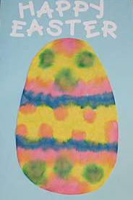
We know that He will come again. (Bring arms down and cross them on chest)
Alleluia! Alleluia! (Twirl twice)
Art Project
The children cut out an oval shape and decorate with various colors of tissue paper.

Fourth Week of Easter
We celebrate New Life! Easter takes place during the spring season. We see evidence of new life all around us. Take a walk in the neighborhood and nearby parks to see the buds on the trees and the insects coming to life. Read stories about baby animals. Celebrate new life with a treat from the Easter basket. Read about Jesus appearing to his friends from a children’s bible or storybook.
Action Poem (based on the Memorial Acclamation)
We remember that Jesus died, (stand with arms outstretched in a cross)
We rejoice that He is risen (bend knees and stretch arms from knees all the way up until standing on tiptoes with hands high up in the air)
We know that He will come again. (Bring arms down and cross them on chest)
Alleluia! Alleluia! (Twirl twice)
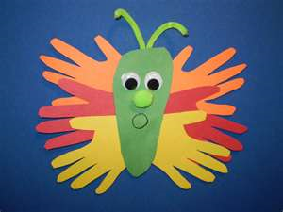
Art Project
Make a bulletin board with the title of ‘New Life’. Add crafts made by the children such as:
Butterflies: the children cut out a butterfly and decorate with scrunched up pieces of tissue paper.
Caterpillars: the children decorate egg cartons to resemble caterpillars.

Fifth Week of Easter
We are still in the Easter Season! Show the children a calendar and count the days from Easter to Pentecost. Stress that this is the most joyful time of the year for Christians. Distribute another treat from the Easter basket. Read about Jesus appearing to his friends from a children’s bible or storybook. Bring holy water to the classroom. Do they remember when the priest sprinkled everyone with holy water on Easter Sunday? Let the children make the sign of the cross using the holy water. Explain how holy water is used during baptism.
Ask them if they have seen the special Easter candle that is lit during this season at church. Show the children a picture of this candle. Talk about Jesus being the ‘Light of the World’.
Action Poem (based on the Memorial Acclamation)
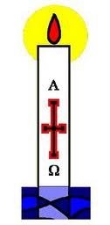
We remember that Jesus died, (stand with arms outstretched in a cross)
We rejoice that He is risen (bend knees and stretch arms from knees all the way up until standing on tiptoes with hands high up in the air)
We know that He will come again. (Bring arms down and cross them on chest)
Alleluia! Alleluia! (Twirl twice)
Art Project
Have the children decorate a drawing of an Easter Candle. Use red glitter/tissue for the flame.

Sixth Week of Easter (The Ascension)
Read the story of the Ascension (Matthew 28:16-20). If it is a nice day, go out into the yard. Have the children pretend they were there when Jesus went home to Heaven. What would they say to Jesus?
Action Poem (based on the Memorial Acclamation)
We remember that Jesus died, (stand with arms outstretched in a cross)
We rejoice that He is risen (bend knees and stretch arms from knees all the way up until standing on tiptoes with hands high up in the air)
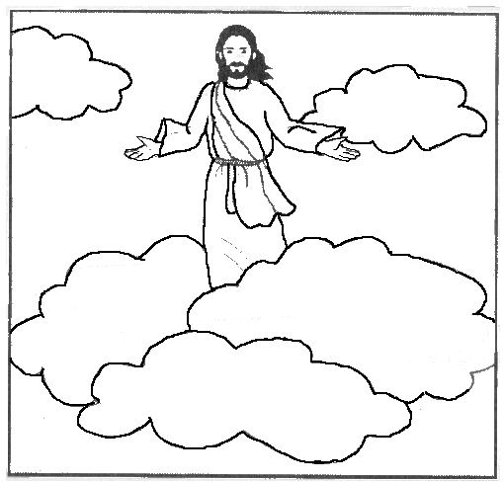
We know that He will come again. (Bring arms down and cross them on chest)
Alleluia! Alleluia! (Twirl twice)
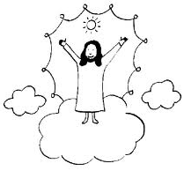
Art Project
Color a picture of Jesus. (You cold use the same picture as in the resurrection). Paste cotton balls on construction paper and paste the picture of Jesus rising above the clouds. Paste on the sentence ‘Jesus goes to Heaven’.

Seventh Week of Easter (Pentecost)
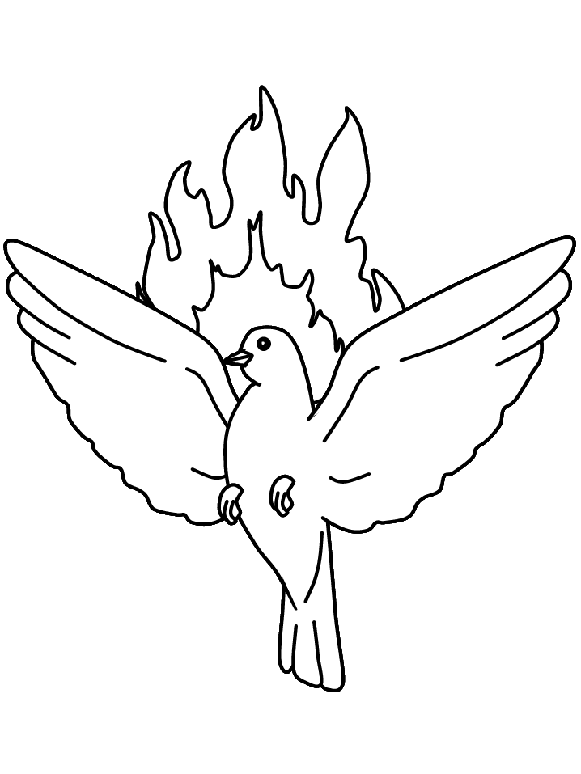
This is our final week of celebration! Read the story of Pentecost (Acts 2) from a children’s bible. Discuss the story: Who was there? What happened?
Action Poem (based on the Memorial Acclamation)
We remember that Jesus died, (stand with arms outstretched in a cross)
We rejoice that He is risen (bend knees and stretch arms from knees all the way up until standing on tiptoes with hands high up in the air)
We know that He will come again. (Bring arms down and cross them on chest)
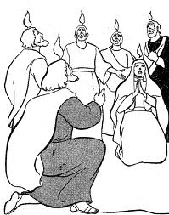
Alleluia! Alleluia! (Twirl twice)
Art Project
Have the children draw a picture of what they heard in the story. Have them paste the word ‘Pentecost’ to their picture.

