Dismissal

The Priest says:

Go in the peace.
OR
Go forth, the mass is ended
OR
Go and announce the Gospel of the Lord
OR
Go in peace, glorifying the Lord by your life.

We say: Thanks be to God.

We sing the closing song, and go out to share God’s love.

My Mass Book
©2011, Catholic Education Services
Regina Catholic Schools

24

My
Mass Book

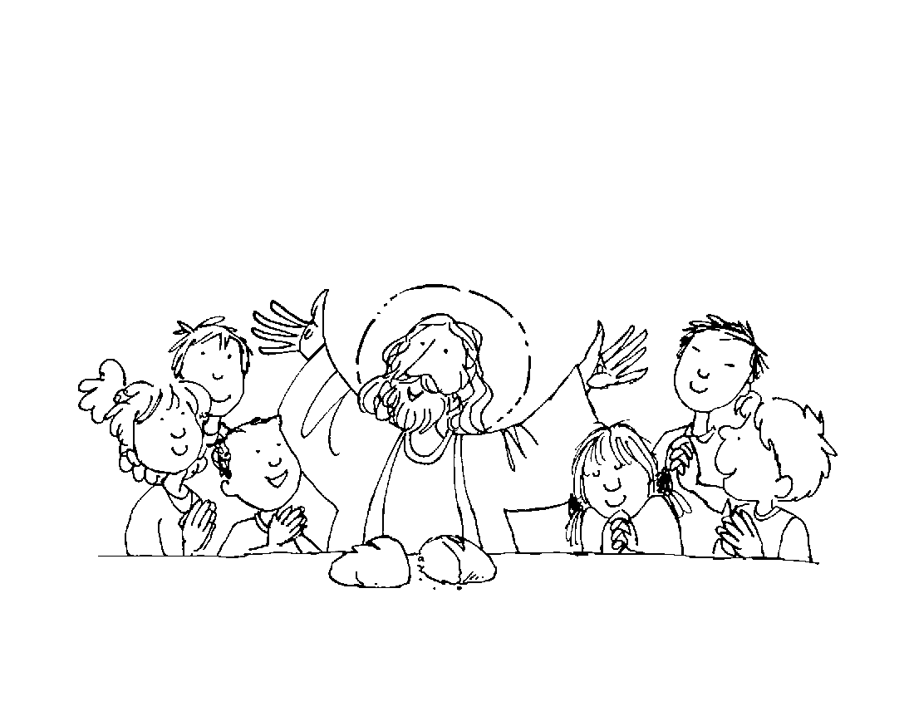

Name___________________

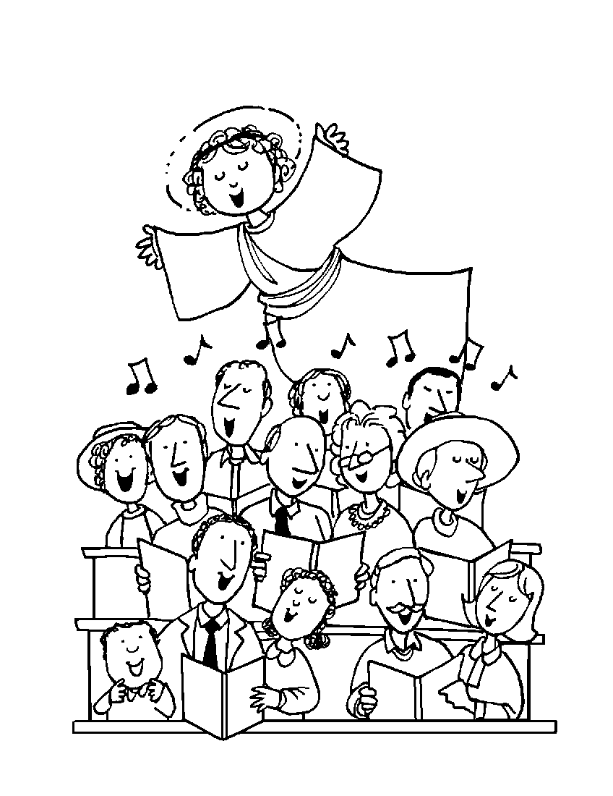

Introductory Rites:
The Procession

We sing the entrance song.
We make the Sign of the Cross.

The Priest says: In the name of the Father, and of the Son, and of the Holy Spirit.

We say: Amen.

The Greeting

The Priest says: The grace of our Lord Jesus Christ and the love of God and the communion of the Holy Spirit be with you all.

We say: And with your spirit.

2
Prayer After Communion

The Priest says a short prayer.

We say: Amen.

Concluding Rites:

The Priest says: The Lord be with you.

We say: And with your spirit.

Blessing

We make the Sign of the Cross.

The Priest says:
May almighty God bless you,
the Father,
and the Son,
and the Holy Spirit.

We say: Amen.

23

Communion
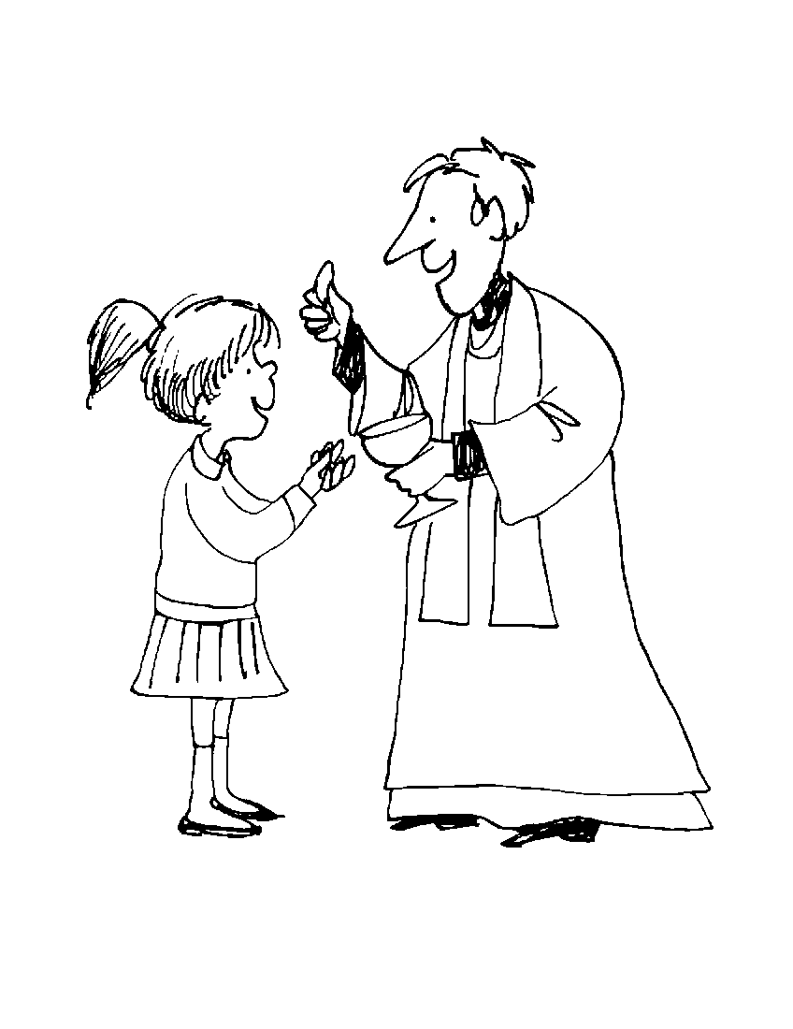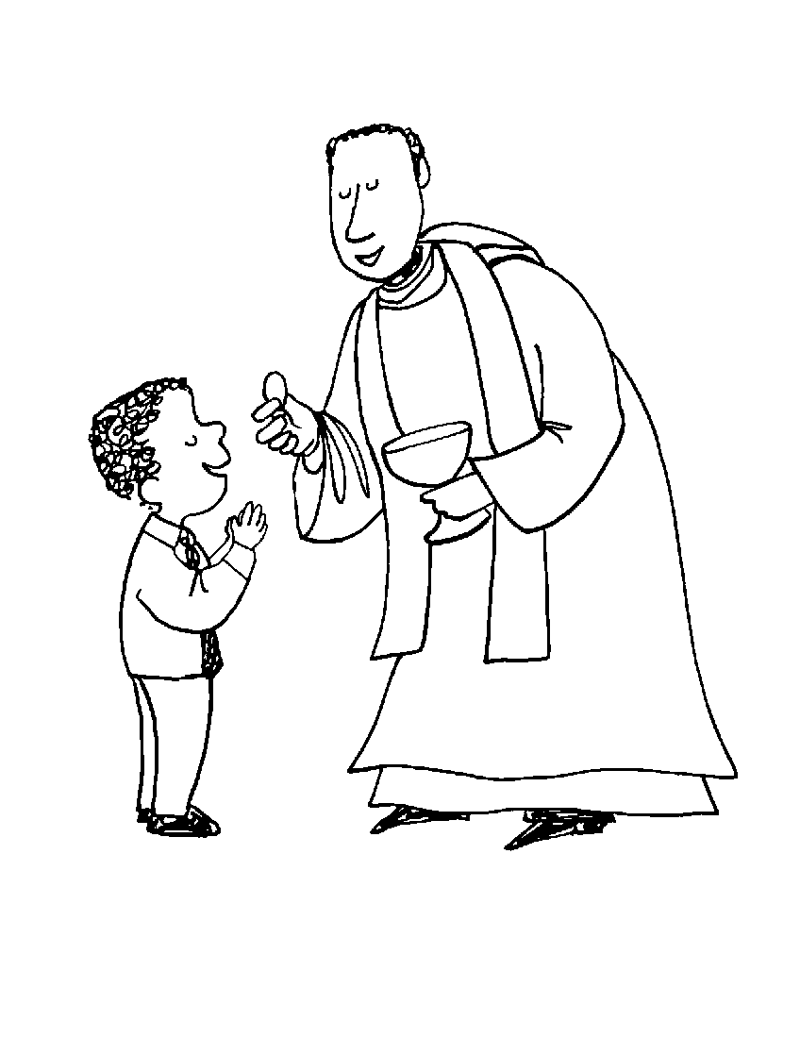
If we are receiving communion, we are to bow our head and then extend our hands. The Priest or Eucharistic Minister says: The body of Christ.
We say: Amen.

If we are not receiving communion, we cross our arms over our chest, and the Priest or Eucharistic Minister says a blessing over us.
We say: Amen.

After communion, we return to our seats, sit down and sing the communion song. Once the song is over, we sit quietly and pray. When the priest says “let us pray”, we stand up.

22

The Penitential Act
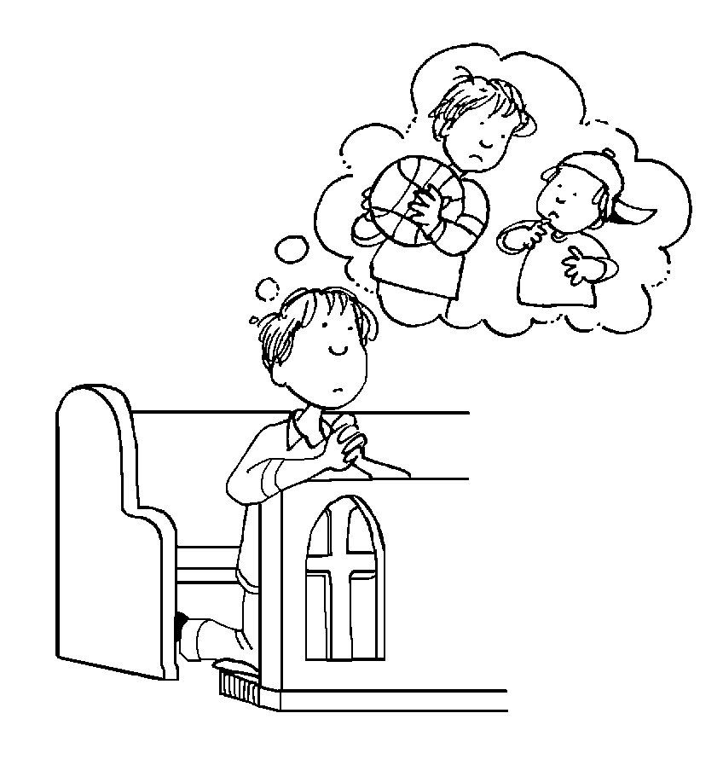
I confess to almighty God and to you, my brothers and sisters, that I have greatly sinned in my thoughts and in my words,
in what I have done, and in what I have failed to do; (and striking our breast we say) through my fault, through my fault, through my most grievous fault; (we continue) therefore I ask blessed Mary, ever virgin, all the angels and saints,
and you, my brothers and sisters,
to pray for me to the Lord our God.

The Priest says: May almighty God have mercy on us, forgive us our sins, and bring us to everlasting life.
We say: Amen.

3

OR
The Priest says: Lord, have mercy.
We say: Lord, have mercy.
The Priest says: Christ, have mercy.
We say: Christ, have mercy.
The Priest says: Lord, have mercy.
We say: Lord, have mercy.

The Priest says: May almighty God have mercy on us, forgive us our sins, and bring us to everlasting life.
We say: Amen.

OR
The Priest says: Have mercy on us, O Lord.
We say: For we have sinned against you
The priest says: Show us, O Lord, your mercy.
We say: And grant us your salvation.

The Priest says: May almighty God have mercy on us, forgive us our sins, and bring us to everlasting life.
We say: Amen.

4

Breaking of Bread

We say:
Lamb of God, you take away the sins of the world:
have mercy on us.

Lamb of God, you take away the sins of the world:
have mercy on us.

Lamb of God, you take away the sins of the world:
grant us peace.

The Priest says: Behold the Lamb of God, behold him who takes away the sins of the world. Blessed are those called to the supper of the Lamb

We say: Lord, I am not worthy that you should enter under my roof, but only say the word and my soul shall be healed.

21

The Sign of Peace
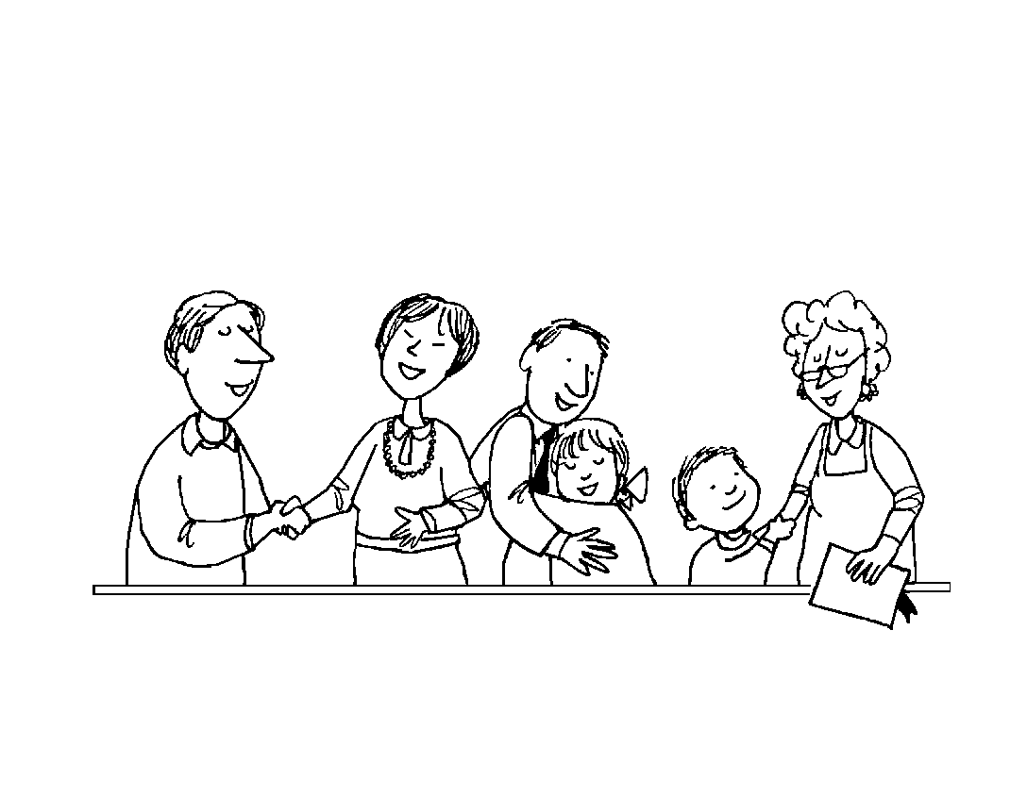
The Priest prays to Christ for peace.

We say: Amen.

The Priest says: The peace of the Lord be with you always.

We say: And with your spirit.

The Priest says: Let us offer each other a sign of peace.

We share the sign of peace with those near us.

20

The Gloria
(on Sundays outside of Advent and Lent usually omitted during Weekday Masses)

Glory to God in the highest, and on earth
peace to people of good will. We praise you, we bless you, we adore you, we glorify you, we give you thanks for your great Glory. Lord, God, heavenly King,
O God, almighty Father.
Lord Jesus Christ, only Begotten Son,
Lord God, Lamb of God, Son of the Father, you take away the sins of the world, have mercy on us; you take away the sins of the world, receive our prayer;
you are seated at the right hand of the Father, have mercy on us.
For you alone are the Holy One,
you alone are the Lord,
you alone are the Most High,
Jesus Christ, with the Holy Spirit,
in the glory of God the Father.
Amen.

5

The Collect (Opening Prayer)

The Priest says: Let us pray.
The Priest says an opening prayer.

We say: Amen.

The Liturgy of the Word:
The First Reading
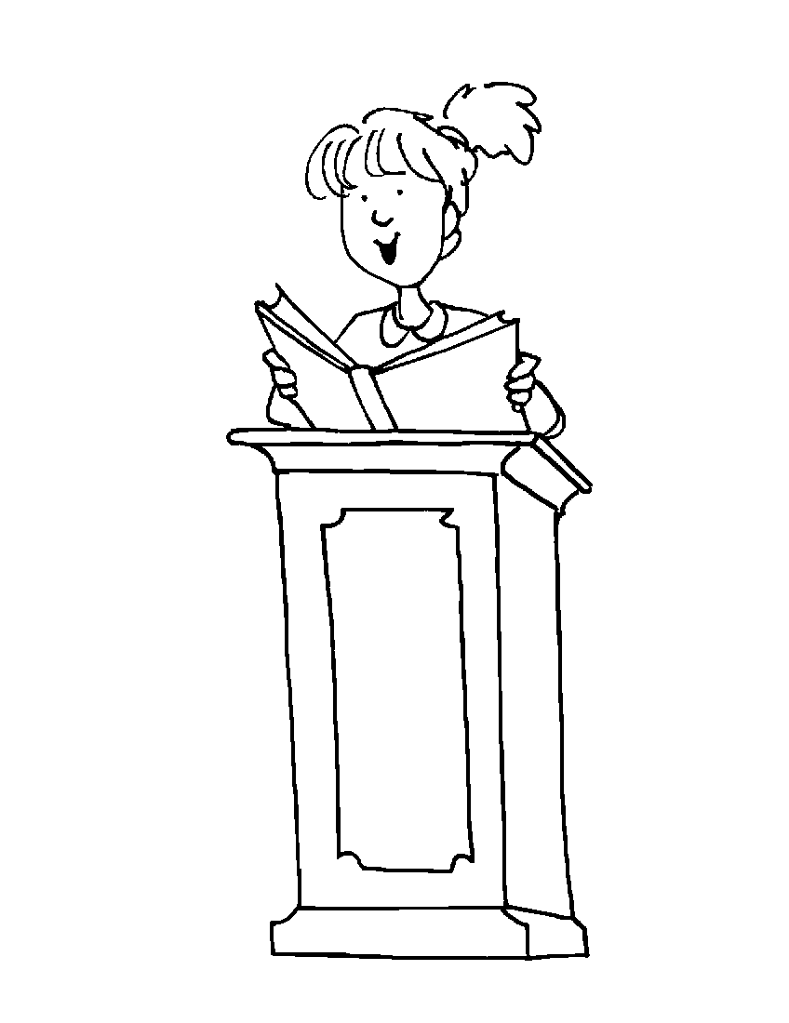
The Lector says: The Word of the Lord.

We say: Thanks be to God.

Responsorial Psalm

Repeat the Psalm response.

6

The Priest says:
Deliver us, Lord, we pray, from every evil, graciously grant peace in our days, that by the help of your mercy, we may be always free from sin and safe from all distress, as we await the blessed hope and the coming of our Saviour, Jesus Christ.

We say:
For the kingdom, the power,
and the glory are yours,
now and for ever.

19

The Lord’s Prayer
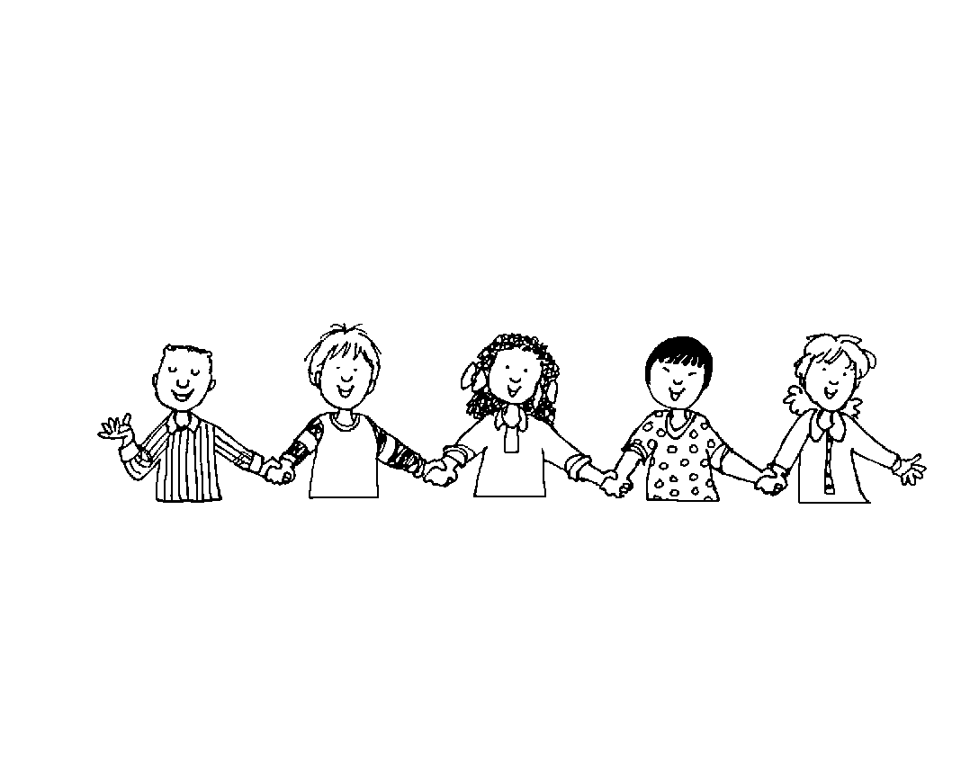
The Priest says: At the Saviour’s command and formed by divine teaching, we dare to say:

We say:
Our Father,
who art in heaven,
hallowed be thy name;
thy kingdom come;
thy will be done on earth
as it is in heaven.
Give us this day our daily bread
and forgive us our trespasses
as we forgive those
who trespass against us;
and lead us not into temptation,
but deliver us from evil.

18

The Second Reading (on Sundays)

The Lector says: The Word of the Lord.

We say: Thanks be to God.

The Gospel
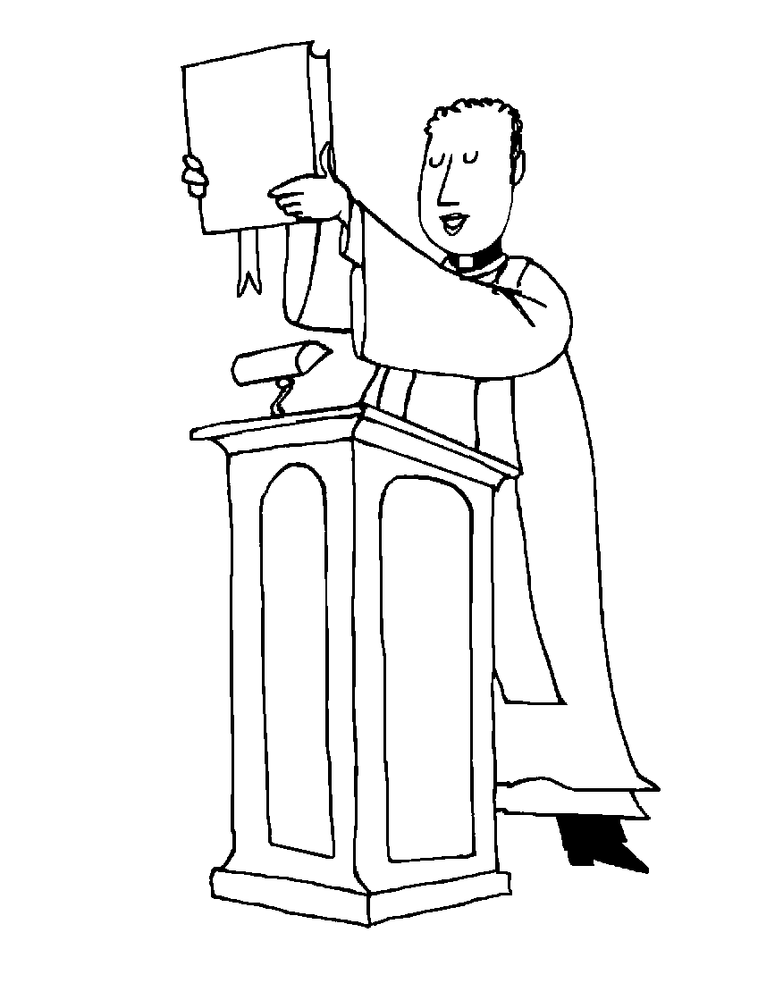
We stand.

We sing a Gospel Acclamation: Alleluia!
(During Lent, we sing: Praise to you, Lord!)

The Priest says: The Lord be with you.

We say: And with your Spirit.

7

The Priest says: A reading from the holy gospel according to ___________.

Make a small cross on your forehead, lips, and heart as you say: Glory to you, O Lord.

At the end of the Gospel, the Priest says: The Gospel of the Lord.

We say: Praise to you, Lord Jesus Christ.

The Homily
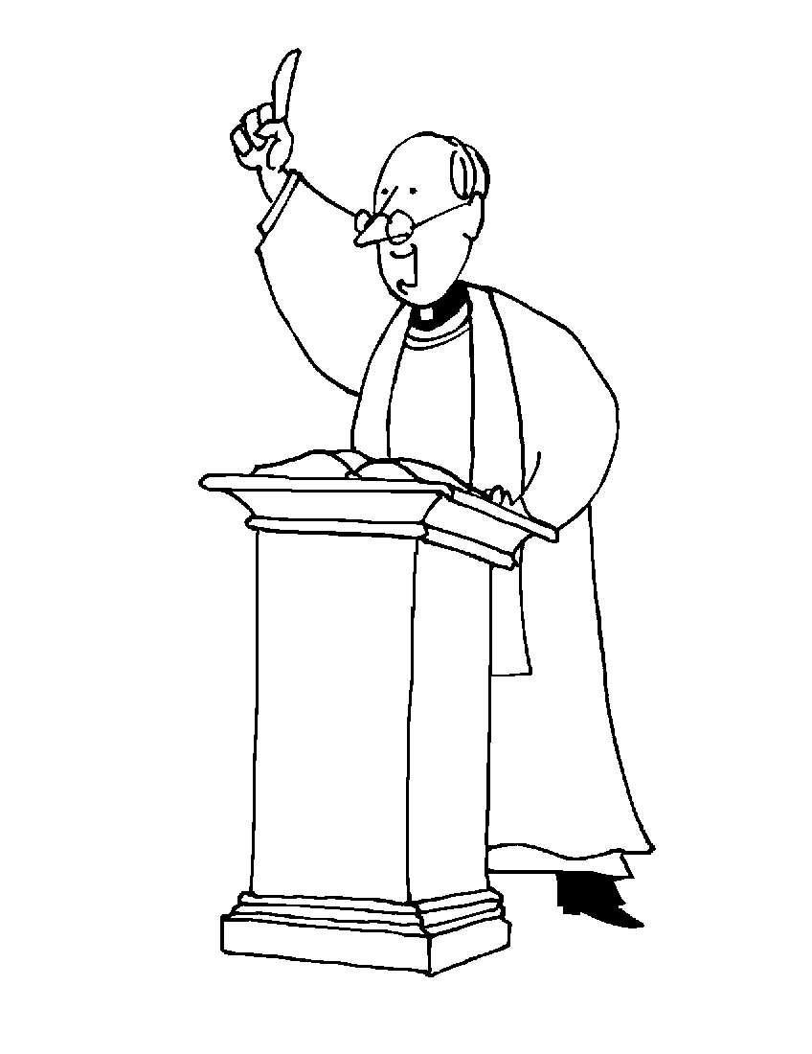
We sit.

The Priest speaks to us about the readings.

8

Memorial Acclamation

The Priest says: the mystery of faith.
We say:

We proclaim your Death, O Lord, and profess your Resurrection until you come again.
OR
When we eat this bread and drink this cup, we proclaim your death, O Lord,
until you come again.
OR
Save us, Saviour of the World, for by your Cross and Resurrection you have set us free.
The Great Amen

The Priest says:
Through him, with him, in him, O God almighty Father, in the unity of the Holy Spirit, all glory and honour is yours, for ever and ever.

We sing or say: Amen.

17
Consecration of Bread and Wine

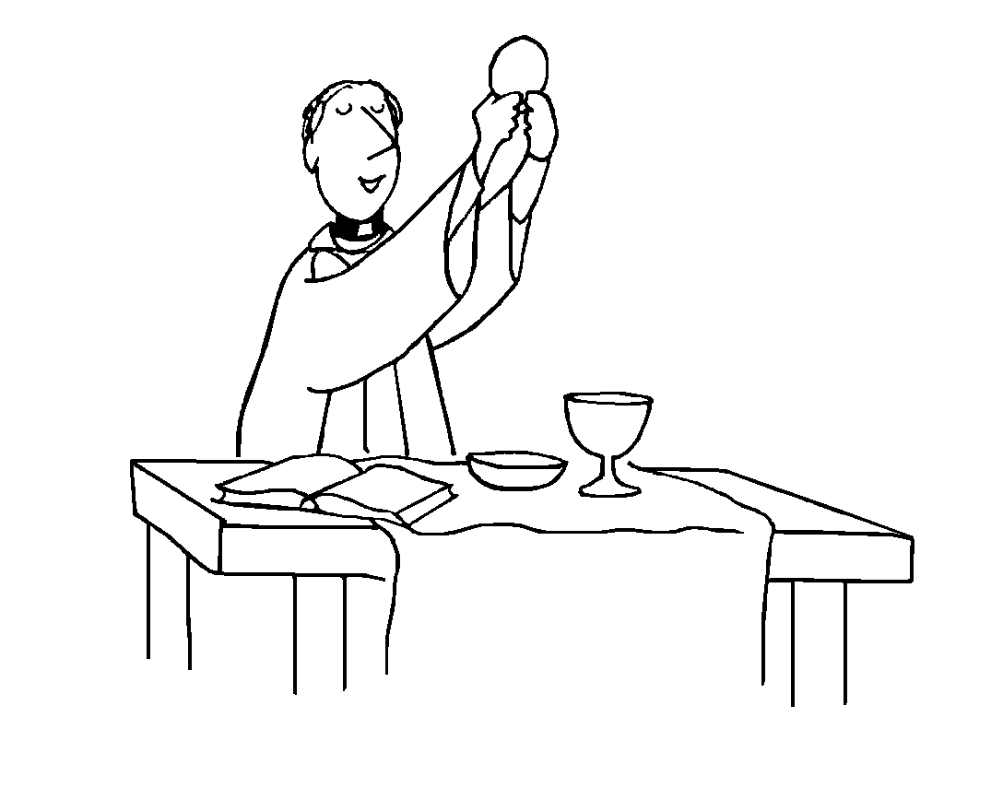
The Priest says:
Take this, all of you, and eat of it, for this is my body which will be given up for you.

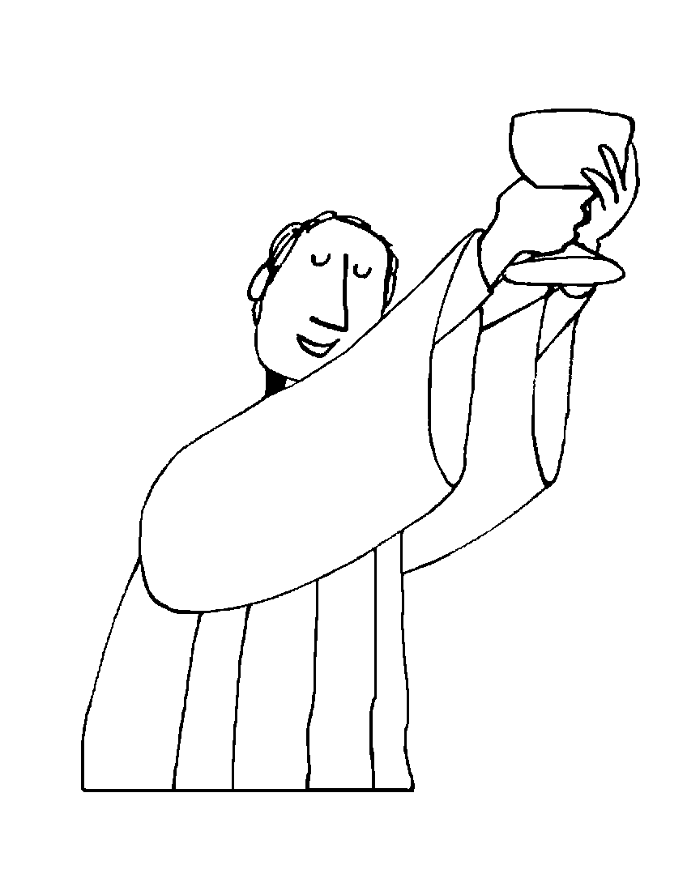
The Priest says:
Take this, all of you, and drink from it, for this is the chalice of my blood, the blood of the new and eternal covenant, which will be poured out for you and for many for the forgiveness of sins. Do this in memory of me.
(If we have been kneeling, we stand right after the priest kneels and stands up again)

16

The Apostles’ Creed (on Sundays)

We stand.

I believe in God, the Father almighty,
creator of heaven and earth and in Jesus Christ, his only Son,our Lord.
(at the words that follow, up to and including the Virgin Mary, we bow)
who was conceived by the power
of the Holy Spirit
and born of the Virgin Mary,
suffered under Pontius Pilate,
was crucified, died, and was buried.
He descended into hell;
on the third day he rose again from the dead; he ascended into heaven, and is seated at the right hand of God the Father Almighty; from there he will come again to judge the living and the dead.

I believe in the Holy Spirit,
the holy catholic Church
the communion of saints,
the forgiveness of sins,
the resurrection of the body,
and life everlasting. Amen.
9
Prayer of the Faithful
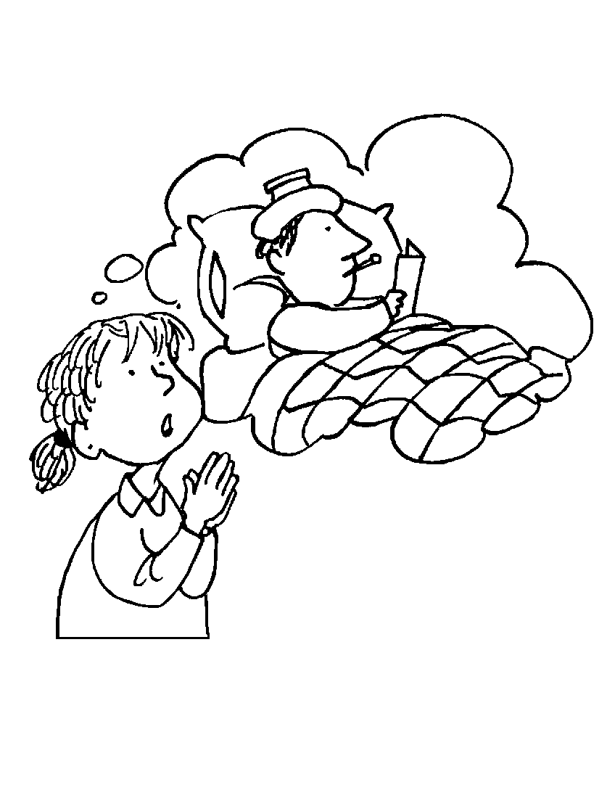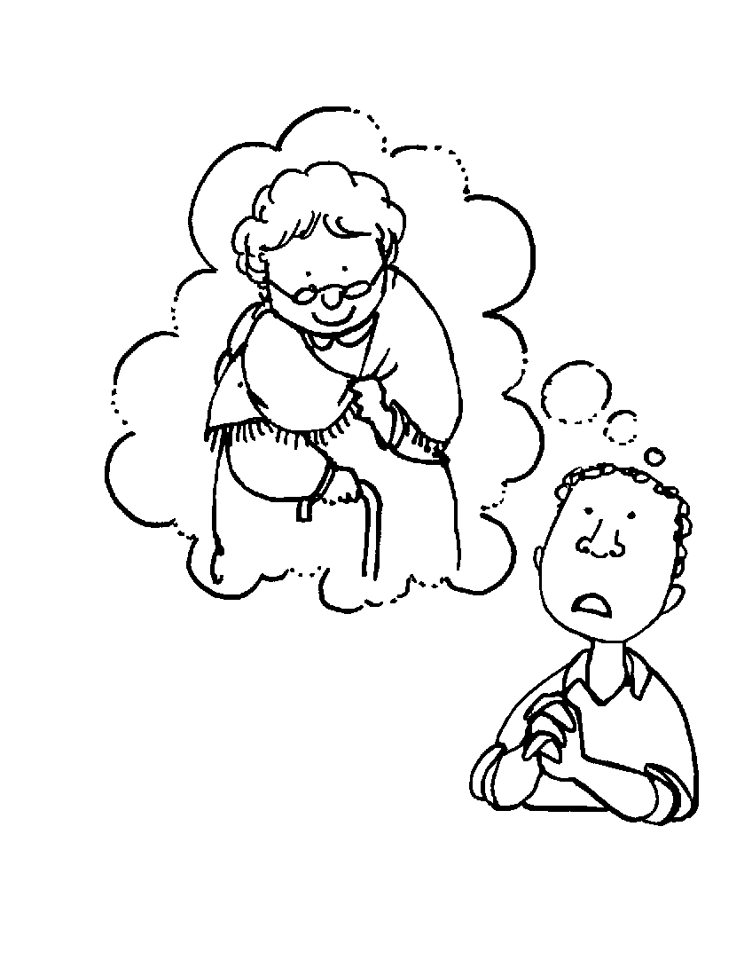
We respond to the prayers of the faithful by saying:
Lord, hear our prayer.

The Priest says a prayer.
We say: Amen.

10

The Preface
The Priest prays.
We say:
Holy, holy, holy Lord,
God of hosts,
heaven and earth are full of your glory.
Hosanna in the highest.
Blessed is he who comes
in the name of the Lord.
Hosanna in the highest.

(If we are in a Church we now kneel down. If we aren’t, we stay standing.)

We listen as the Priest says:
Make holy, therefore, these gifts, we pray, by sending down your Spirit upon them like the dewfall, so that they may become for us the Body and Blood of our Lord Jesus Christ

15

The Eucharistic Prayer

We stand.

The Priest says: The Lord be with you.
We say: And with your spirit.

The Priest says: Lift up your hearts.
We say: We lift them up to the Lord.

The Priest says: Let us give thanks to the Lord our God.
We say: It is right and just.

14

The Liturgy of the Eucharist:
Preparation of the Altar
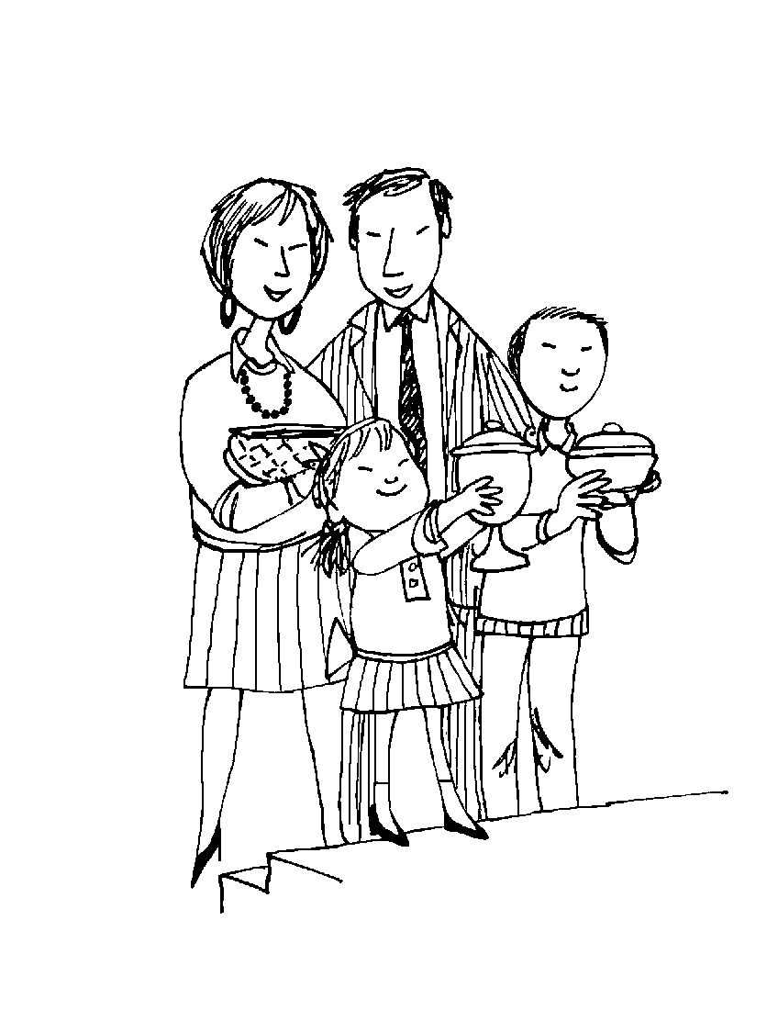
We sit.

The gifts are brought to the altar.

11

Preparation of the Bread

The Priest says:
Blessed are you, Lord, God of all creation for through your goodness
we have received this bread we offer you;
fruit of the earth and work of human hands,
it will become for us the bread of life.

We say: Blessed be God for ever.

Preparation of the Wine

The Priest says:
Blessed are you, Lord, God of all creation for
through your goodness we have received the wine we offer you; fruit of the vine and work of human hands, it will become our spiritual drink.

We say: Blessed be God for ever.

12

Washing of Hands

The Priest washes his hands and says:
Wash me, O Lord, from my iniquity and
cleanse me from my sin.

Prayer Over the Gifts

The Priest says:
Pray, brothers and sisters,
that my sacrifice and yours may be acceptable to God, the almighty Father.

We say:
May the Lord accept
the sacrifice at your hands
for the praise and glory of his name,
for our good,
and the good of all his holy Church.

The Priest prays over the gifts.
We say: Amen.

13

