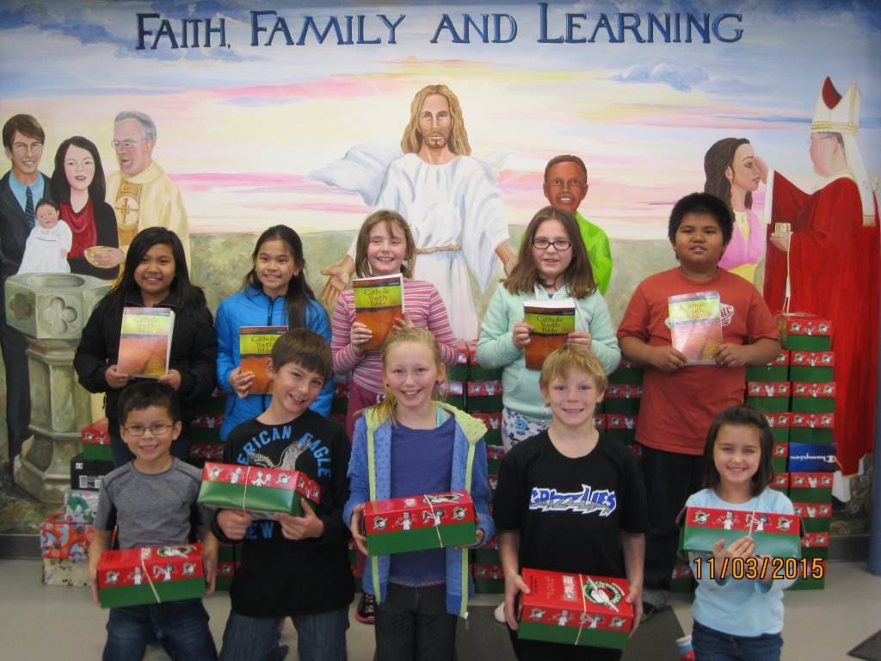The Encompassing Impact of Faith Education
“May they all be one” was God’s wish for all his people and it is through faith education that we breathe life into these words that Jesus spoke. It is within our Catholic schools that we have the freedom to proclaim the Good News and as teachers we introduce and guide students and families towards fulfilling their life-long faith journey. Our students develop close meaningful relationships with the Gospel on a daily basis. We plant the seed of the Gospel and it is woven into the fabric of every Catholic building across our province being felt the moment you enter our doors and shining forth every second of the day.
Our students experience first-hand the greatest of all commandments that being, “Love the Lord, your God with all your heart, all your soul, and all your strength.” Our praise and worship brightens and fills the heart of each child. Our school masses and prayer celebrations open our minds and hearts to grow towards a close and personal relationship with Jesus and God. We experience the power of prayer in all that we do and our service projects guide us in growing up into an aware, compassionate and merciful people. Throughout our daily interactions we have Jesus at the core, and it is from Him that all our learning is driven. Through Him we are engaged and represent true Christian discipleship. We are blessed that faith education within our schools brings meaning to each day. It is the common thread that gives us purpose and direction towards living a life that is truly holy in God’s eyes.

