A Framework for Gathered Prayer
Gather/Call
The first part of the prayer needs to help those who are gathered to become aware of their relationship with God and their relationship to each other. As the group conies together to pray what actions, gestures, music, singing, proclamations, litanies or other preparations will help this to occur?

Listen/Word
The next movement of the prayer gives those now gathered a chance to hear the scriptures or current stories which allow us to reflect on how God is active in our lives. Readings, drama, videos, personal stories, witness reflections, music, songs, psalms, gestures, litanies and silence are some elements which might be included.

Respond/Ritual
The third movement of prayer reminds us that it is not enough to just hear the word of God, we must keep it. How will we respond to our awareness of how God continues to love us unconditionally? Spontaneous and composed prayers, intercessory prayers, the Lord’s prayer, psalms, music, actions or gestures are options

Send Forth
The final movement of prayer sends us forth with a renewed sense of our mission to live the Gospel each and everyday. Prayer helps us to focus on the big picture but also the simple ways that each of us needs to be a disciple to those around us. Spontaneous and composed prayers, music, songs, actions and gestures, blessings, commissioning, exchanging a sign of peace are some of the ways this can occur.
SELECT: Set up/Décor; Assembly Preparation; call to prayer; Songs; Music; Actions; Processions; Gestures.

SELECT: Scriptures; Current Readings; Psalms; Witnesses; Storytelling; Sharing; Music; Songs; Reflections; Journaling

SELECT; Ritual Actions; Gestures; Songs; Music; Reflections; Psalms; Intercessions; Lord’s Prayer

SELECT: Blessings; Commissions; Songs; Closing Prauers; Actions; Sign of Peace; Processions

You Who Do Through

Many people find it hard to pray using their own words. For some, they can only ever use words once spoken by someone else to join their hearts to God, and while the Christian heritage has some great prayers, it's important to be able to put our own words into prayer too.

Today we have a model for prayer which I think might be worth holding onto. It's "You - who - do - through"

that is
1. Addressing God in first person - You
2. Saying something about God, and/or thanking God- who
3. Making a request to God - do
4. Concluding the prayer in a Trinitarian way - through Jesus and with the Holy Spirit.

e.g.
1. God, giver of all life
2. You are the one who has made us in your image and made our hearts yearn for you
3. Please open my heart more and more to you. Show me the things in my life which keep me from loving you and other and help me to remove them.
4. I ask this through Christ, our Lord, Amen.

Easy Eh!

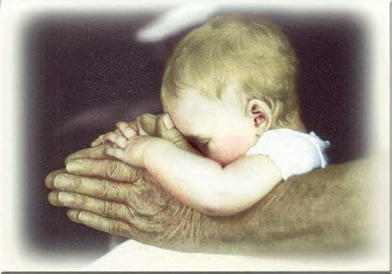
Just remember you-who-do-through, and fill in the blanks with whatever you want to say.

When we pray we are held in the arms of Jesus and together our prayers go to God!

